Exercise 1: Inventory Management System
Code:
using System;
using System.Collections.Generic;
class Product
{
public int ProductId { get; set; }
public string ProductName { get; set; }
public int Quantity { get; set; }
public double Price { get; set; }
public Product(int id, string name, int quantity, double price)
{
ProductId = id;
ProductName = name;
Quantity = quantity;
Price = price;
}
public override string ToString()
{
return $"ID: {ProductId}, Name: {ProductName}, Qty: {Quantity}, Price: ₹{Price}";
}
}
class Inventory
{
private Dictionary<int, Product> products = new Dictionary<int, Product>();
public void AddProduct(Product product)
{
products[product.ProductId] = product;
Console.WriteLine("Product Added");
}
public void UpdateProduct(int id, int quantity, double price)
{
if (products.ContainsKey(id))
{
products[id].Quantity = quantity;
products[id].Price = price;
Console.WriteLine("Product Updated");
}
else
{
Console.WriteLine("Product Not Found");
}
}
public void DeleteProduct(int id)
{
if (products.Remove(id))
Console.WriteLine("Product Deleted");
else
Console.WriteLine("Product Not Found");
}
public void DisplayProducts()
{
Console.WriteLine("\nInventory:");
foreach (var product in products.Values)
{
Console.WriteLine(product);
}
}
}
class Program
{
static void Main()
{
Inventory inventory = new Inventory();
inventory.AddProduct(new Product(1, "Laptop", 10, 50000));
inventory.AddProduct(new Product(2, "Mouse", 50, 500));
inventory.DisplayProducts();
inventory.UpdateProduct(1, 15, 52000);
inventory.DisplayProducts();
inventory.DeleteProduct(2);
inventory.DisplayProducts();
}
}
Output:

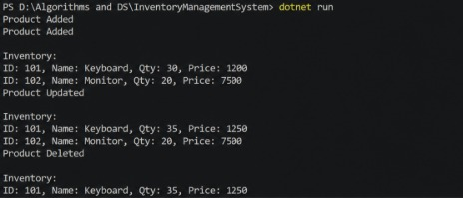

Exercise 2: E-commerce Platform Search Function
Code:
using System;
class Product
{
public int ProductId { get; set; }
public string ProductName { get; set; }
public string Category { get; set; }
public Product(int id, string name, string category)
{
ProductId = id;
ProductName = name;
Category = category;
}
}
class Program
{
static Product LinearSearch(Product[] products, string name)
{
foreach (Product p in products)
{
if (p.ProductName.Equals(name, StringComparison.OrdinalIgnoreCase))
return p;
}
return null;
}
static Product BinarySearch(Product[] products, string name)
{
int left = 0;
int right = products.Length - 1;
while (left <= right)
{
int mid = (left + right) / 2;
int comparison =
string.Compare(products[mid].ProductName,
name,
true);
if (comparison == 0)
return products[mid];
if (comparison < 0)
left = mid + 1;
else
right = mid - 1;
}
return null;
}
static void Main()
{
Product[] products =
{
new Product(1, "Keyboard", "Electronics"),
new Product(2, "Laptop", "Electronics"),
new Product(3, "Mobile", "Electronics"),
new Product(4, "Mouse", "Electronics"),
new Product(5, "Tablet", "Electronics")
};
Product result1 = LinearSearch(products, "Mouse");
Console.WriteLine("Linear Search:");
if (result1 != null)
Console.WriteLine($"{result1.ProductId} - {result1.ProductName}");
Product result2 = BinarySearch(products, "Mouse");
Console.WriteLine("\nBinary Search:");
if (result2 != null)
Console.WriteLine($"{result2.ProductId} - {result2.ProductName}");
}
}

Output:

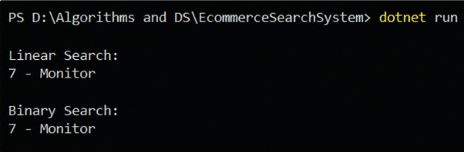
Exercise 3: Sorting Customer Orders
Code:
using System;
class Order
{
public int OrderId { get; set; }
public string CustomerName { get; set; }
public double TotalPrice { get; set; }
public Order(int id, string name, double price)
{
OrderId = id;
CustomerName = name;
TotalPrice = price;
}
}
class Program
{
static void DisplayOrders(Order[] orders)
{
foreach (var order in orders)
{
Console.WriteLine(
$"ID: {order.OrderId}, " +
$"Customer: {order.CustomerName}, " +
$"Price: ₹{order.TotalPrice}");
}
}
static void BubbleSort(Order[] orders)
{
int n = orders.Length;
for (int i = 0; i < n - 1; i++)
{
for (int j = 0; j < n - i - 1; j++)
{
if (orders[j].TotalPrice > orders[j + 1].TotalPrice)
{
Order temp = orders[j];
orders[j] = orders[j + 1];
orders[j + 1] = temp;
}
}
}
}
static void QuickSort(Order[] orders, int low, int high)
{
if (low < high)
{
int pi = Partition(orders, low, high);
QuickSort(orders, low, pi - 1);
QuickSort(orders, pi + 1, high);
}
}
static int Partition(Order[] orders, int low, int high)
{
double pivot = orders[high].TotalPrice;
int i = low - 1;
for (int j = low; j < high; j++)
{
if (orders[j].TotalPrice < pivot)
{
i++;
Order temp = orders[i];
orders[i] = orders[j];
orders[j] = temp;
}
}
Order temp1 = orders[i + 1];
orders[i + 1] = orders[high];
orders[high] = temp1;
return i + 1;
}
static void Main()
{
Order[] orders =
{
new Order(1, "Alice", 5000),
new Order(2, "Bob", 2000),
new Order(3, "Charlie", 8000),
new Order(4, "David", 3000)
};
Console.WriteLine("Before Sorting:");
DisplayOrders(orders);
BubbleSort(orders);
Console.WriteLine("\nAfter Bubble Sort:");
DisplayOrders(orders);
Order[] orders2 =
{
new Order(1, "Alice", 5000),
new Order(2, "Bob", 2000),
new Order(3, "Charlie", 8000),
new Order(4, "David", 3000)
};
QuickSort(orders2, 0, orders2.Length - 1);
Console.WriteLine("\nAfter Quick Sort:");
DisplayOrders(orders2);
}
}

Output:
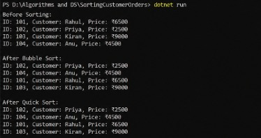

Exercise 4: Employee Management System
Code:
using System;
class Employee
{
public int EmployeeId { get; set; }
public string Name { get; set; }
public string Position { get; set; }
public double Salary { get; set; }
public Employee(int id, string name, string position, double salary)
{
EmployeeId = id;
Name = name;
Position = position;
Salary = salary;
}
public override string ToString()
{
return $"ID: {EmployeeId}, Name: {Name}, Position: {Position}, Salary: ₹{Salary}";
}
}
class EmployeeManager
{
private Employee[] employees;
private int count = 0;
public EmployeeManager(int size)
{
employees = new Employee[size];
}
public void AddEmployee(Employee emp)
{
if (count < employees.Length)
{
employees[count++] = emp;
Console.WriteLine("Employee Added");
}
else
{
Console.WriteLine("Array Full");
}
}
public Employee SearchEmployee(int id)
{
for (int i = 0; i < count; i++)
{
if (employees[i].EmployeeId == id)
return employees[i];
}
return null;
}
public void DeleteEmployee(int id)
{
for (int i = 0; i < count; i++)
{
if (employees[i].EmployeeId == id)
{
for (int j = i; j < count - 1; j++)
{
employees[j] = employees[j + 1];
}
employees[count - 1] = null;
count--;
Console.WriteLine("Employee Deleted");
return;
}
}
Console.WriteLine("Employee Not Found");
}
public void TraverseEmployees()
{
Console.WriteLine("\nEmployee Records:");
for (int i = 0; i < count; i++)
{
Console.WriteLine(employees[i]);
}
}
}
class Program
{
static void Main()
{
EmployeeManager manager = new EmployeeManager(10);
manager.AddEmployee(new Employee(101, "Dharani", "Developer", 50000));
manager.AddEmployee(new Employee(102, "Priya", "Tester", 40000));
manager.TraverseEmployees();
Console.WriteLine("\nSearching Employee 101:");
Employee emp = manager.SearchEmployee(101);
if (emp != null)
Console.WriteLine(emp);
manager.DeleteEmployee(102);
manager.TraverseEmployees();
}
}

Output:
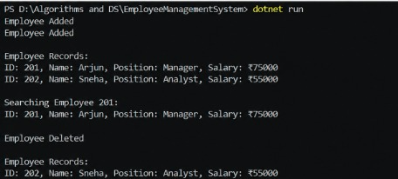

Exercise 5: Task Management System
Code:
using System;
class TaskNode
{
public int TaskId;
public string TaskName;
public string Status;
public TaskNode Next;
public TaskNode(int id, string name, string status)
{
TaskId = id;
TaskName = name;
Status = status;
Next = null;
}
}
class TaskLinkedList
{
private TaskNode head;
public void AddTask(int id, string name, string status)
{
TaskNode newNode = new TaskNode(id, name, status);
if (head == null)
{
head = newNode;
return;
}
TaskNode temp = head;
while (temp.Next != null)
{
temp = temp.Next;
}
temp.Next = newNode;
}
public void TraverseTasks()
{
Console.WriteLine("\nTask List:");
TaskNode temp = head;
while (temp != null)
{
Console.WriteLine(
$"ID: {temp.TaskId}, Name: {temp.TaskName}, Status: {temp.Status}");
temp = temp.Next;
}
}
public void SearchTask(int id)
{
TaskNode temp = head;
while (temp != null)
{
if (temp.TaskId == id)
{
Console.WriteLine(
$"Found -> ID: {temp.TaskId}, Name: {temp.TaskName}, Status: {temp.Status}");
return;
}
temp = temp.Next;
}
Console.WriteLine("Task Not Found");
}
public void DeleteTask(int id)
{
if (head == null)
return;
if (head.TaskId == id)
{
head = head.Next;
Console.WriteLine("Task Deleted");
return;
}
TaskNode temp = head;
while (temp.Next != null && temp.Next.TaskId != id)
{
temp = temp.Next;
}
if (temp.Next != null)
{
temp.Next = temp.Next.Next;
Console.WriteLine("Task Deleted");
}
else
{
Console.WriteLine("Task Not Found");
}
}
}
class Program
{
static void Main()
{
TaskLinkedList tasks = new TaskLinkedList();
tasks.AddTask(1, "Design UI", "Pending");
tasks.AddTask(2, "Write Code", "In Progress");
tasks.AddTask(3, "Testing", "Pending");
tasks.TraverseTasks();
Console.WriteLine("\nSearching Task 2:");
tasks.SearchTask(2);
Console.WriteLine("\nDeleting Task 2:");
tasks.DeleteTask(2);
tasks.TraverseTasks();
}
}

Output:
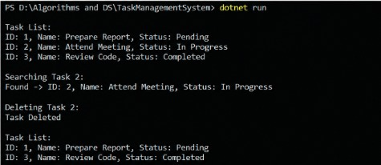

Exercise 6: Library Management System
Code:
using System;
class Book
{
public int BookId { get; set; }
public string Title { get; set; }
public string Author { get; set; }
public Book(int id, string title, string author)
{
BookId = id;
Title = title;
Author = author;
}
}
class Program
{
// Linear Search
static Book LinearSearch(Book[] books, string title)
{
foreach (Book book in books)
{
if (book.Title.Equals(title, StringComparison.OrdinalIgnoreCase))
return book;
}
return null;
}
static Book BinarySearch(Book[] books, string title)
{
int left = 0;
int right = books.Length - 1;
while (left <= right)
{
int mid = (left + right) / 2;
int result = string.Compare(
books[mid].Title,
title,
true
);
if (result == 0)
return books[mid];
if (result < 0)
left = mid + 1;
else
right = mid - 1;
}
return null;
}
static void Main()
{
// Sorted by Title
Book[] books =
{
new Book(101, "C Programming", "Dennis Ritchie"),
new Book(102, "Data Structures", "Mark Allen"),
new Book(103, "Java Basics", "James Gosling"),
new Book(104, "Python Guide", "Guido van Rossum"),
new Book(105, "Web Development", "Tim Berners-Lee")
};
Console.WriteLine("Linear Search:");
Book book1 = LinearSearch(books, "Python Guide");
if (book1 != null)
Console.WriteLine(
$"{book1.BookId} - {book1.Title} - {book1.Author}");
Console.WriteLine("\nBinary Search:");
Book book2 = BinarySearch(books, "Python Guide");
if (book2 != null)
Console.WriteLine(
$"{book2.BookId} - {book2.Title} - {book2.Author}");
}
}

Output:
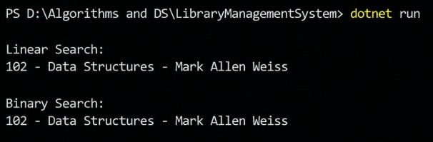

Exercise 7: Financial Forecasting
Code:
using System;
class FinancialForecast
{
// Recursive method
public static double PredictFutureValue(
double currentValue,
double growthRate,
int years)
{
if (years == 0)
return currentValue;
return PredictFutureValue(
currentValue * (1 + growthRate),
growthRate,
years - 1
);
}
}
class Program
{
static void Main()
{
double currentValue = 10000;
double growthRate = 0.10; // 10%
int years = 5;
double futureValue =
FinancialForecast.PredictFutureValue(
currentValue,
growthRate,
years
);
Console.WriteLine($"Current Value : ₹{currentValue}");
Console.WriteLine($"Growth Rate : {growthRate * 100}%");
Console.WriteLine($"Years : {years}");
Console.WriteLine($"Future Value : ₹{futureValue:F2}");
}
}

Output:

